SoRoSim Toolbox V7.0 – MATLAB Installation Guide

1. Downloading SoRoSim Toolbox
1. Go to: https://www.mathworks.com/matlabcentral/fileexchange/83038-sorosim and download the V7.0 .zip file from the Version History tab.
2. Unzip the file and place the folder in a convenient location (recommended: Documents\MATLAB).
3. Open MATLAB and add the toolbox to your path by typing in the Command Window:
addpath(genpath('SoRoSim folder location'))
4. Verify installation by typing path. You should see the SoRoSim folder, and its subfolders listed.

2. Installing Optimization Toolbox (skip if already installed)
1. In MATLAB, go to HOME → Add-Ons → Get Add-Ons.
2. Search for Optimization Toolbox and install it.

3. Creating a SoRoSim Link
1. Create a link with:
L1 = SorosimLink
2. Select:
- Soft → deformable links
- Rigid → non-deformable links
3. For Soft Links, define the following properties:
- Joint type – degrees of freedom at the proximal end
- Cross section – link geometry
- Joint stiffness – (set to 0 for rigid joint)
- Divisions – number of cross-section variations (default = 1)
- Density – e.g., PLA = 1240 kg/m³
- Young’s Modulus (E) – PLA ≈ 2.4×10⁹ Pa
- Poisson’s Ratio (ν) – PLA ≈ 0.34
- Material damping – for dynamics (0 for statics)
- Length
- Initial radius
- Final radius

Soft Link Material Defaults (PLA)
Property | Symbol | Typical Value | Units | Notes
Density | ρ | 1240 | kg/m³ | Use 0 for statics where mass is ignored
Young's Modulus | E | 2.4×10⁹ | Pa | Material stiffness
Poisson’s Ratio | ν | 0.34 | — | Transverse contraction
Material Damping | c | 0 (statics) | — | Only for dynamic simulations

Geometry fields (Length, Initial radius, Final radius) depend on your design. leave Divisions = 1 unless you need varying cross-sections or varying tendon actuation on specific sections of the length.

4. Creating a SoRoSim Linkage
1. Create a linkage with:
S1 = SorosimLinkage(L1)
2. Select the link name and define the proximal-end location/orientation. Click Apply for preview, Done to confirm.
3. Define linkage DOFs (recommended order = 3 for nonlinear bending).
4. Set quadrature points (20+ recommended). All links must use the same number to avoid errors.
5. Specify closed-loop joints (usually 0).
6. Enable/disable gravity and set its direction.
7. Add point forces if desired:
- Choose local frame (follower wrench) or global frame (non-follower wrench)
- Select link, division (usually 1), and position (0 = proximal, 1 = distal)
- Define wrench vector
8. Define if the system is actuated:
- Proximal joint: Choose wrench control (input wrench → solve for position) or position control (input position → solve for wrench)
- Soft actuators (tendons): Define number, path type, and link divisions. Useful for antagonistic wrists. During simulation, input tendon tensions.

5. Saving and Loading Models
Save a model:
cd('chosen_directory')
save('model_name.mat','link_variable_name','linkage_variable_name')
Load a model:
cd('directory_of_saved_model')
load('model_name.mat')
Your link and linkage variables will reappear in the Workspace.

6. Running a Statics Simulation
1. For a linkage called S1, run a statics simulation with:
S1.statics()
2. You will be prompted to enter joint values: initial position for position-controlled joints, and initial wrench for wrench-controlled joints.
3. If you have tendons, you will be prompted to enter the tension in each tendon.
4. You will be prompted to enter an initial guess for joint/coordinate wrenches. Leave this as all zeros.
5. The solver computes the deflected configuration and outputs the final shape along with the resulting wrench or position of each joint in the deflected state.
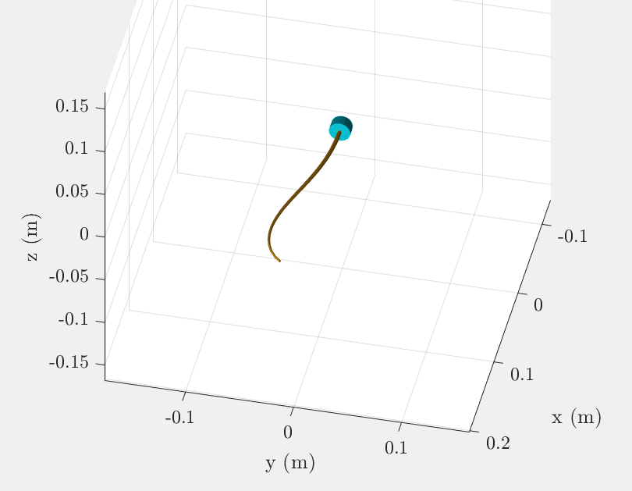
Figure 1: A statics simulation of a tapered beam with a point force acting in the -y direction and tendon actuation curving the continuum robot to the right.

